

A Project Report on

**Generating Literature Review for Research Paper**

Submitted in partial fulfilment for the award of the degree of

**Master in Business Administration**

In **Business Analytics**

Submitted by

**Sanjeev Kumar Jha**

R19MBA06

Under the Guidance of

**Dr. J.B.Simha**

Chief Mentor

REVA Academy for Corporate Excellence

**REVA University**

Rukmini Knowledge Park, Kattigenahalli,

Yelahanka, Bangalore – 560064

**November 2021**



# Candidate’s Declaration

I, Sanjeev Kumar Jha hereby declare that I have completed the project work towards the Master in Business Administration at, REVA University on the topic entitled **Generating Literature Review for Research Paper** under the supervision of **Dr.J.B.Simha**, Chief Mentor. This report embodies the original work done by me in partial fulfilment of the requirements for the award of the degree for the academic year 2020.

Sanjeev Kumar Jha

Place: Bengaluru Name of the Student:

Date: 13th Nov 2021 Signature of Student



# Certificate

This is to Certify that the Project work entitled **Generating Literature Review for Research Paper** carried out by **Sanjeev Kumar Jha** with R19MBA06**,** is a bonafide student of REVA University, is submitting the first-year project report in fulfilment for the award of Master in Business Administrationin Business Analytics during the academic year 2021. The Project report has been tested for plagiarism and has passed the plagiarism test with a similarity score of less than 15%. The project report has been approved as it satisfies the academic requirements in respect of the project work prescribed for the said Degree.

Signature of the Guide Signature of the Director

Name of the Guide Name of the Director

External Viva

Names of the Examiners

Place: Bengaluru

Date: 13th Nov,2021



# Acknowledgement

Please acknowledge the role of your mentors, trainers, classmates, program office members, family and friends who have directly and indirectly supported you in this work.

Please acknowledge the support provided by Hon’ble Chancellor, Dr. P Shayma Raju, Pro-Vice Chancellor, Dr. M. Dhanamjaya, Registrar, Dr. Beena G. as a standard protocol.

Place: Bengaluru

Date: 13th -Nov-2021



# Similarity Index Report

This is to certify that this project report titled Generating Literature Review for Research Paper was scanned for similarity detection. Process and outcome is given below.

Software Used:

Date of Report Generation:

Similarity Index in %:

Total word count:

Name of the Guide:

Place: Bengaluru Name of the Student: Sanjeev Kumar Jha

Date: 13th- Nov-2021 Signature of Student

Verified by:

Signature

Dr. Shinu Abhi,

Director, Corporate Training

# List of Abbreviations

|  |  |  |
| --- | --- | --- |
| **Sl. No** | **Abbreviation** | **Long Form** |
| 1 | NLP | Natural Language Processing |
| 2 | TM | Text Mining |
|  | SLRs | Systematic Literature Reviews |
|  | LSA | Latent Semantic Analysis |
|  | BERT | Bidirectional Encoder Representations from Transformers |
|  | GPT-2 | Generative Pretrained Transformer 2 |
|  | Rough | Recall-Oriented Understudy for Gisting Evaluation |
|  | Blue | Bilingual Evaluation Understudy |

# List of Figures

|  |  |  |
| --- | --- | --- |
| **No.** | **Name** | **Page No.** |
| 1 | Text Pre-process | 30 |
| 2 | Text Rank Architecture | 31 |
| 3 | BERT Architecture | 33 |
| 4 | GPT-2 Architecture | 33 |
| 5 | Text Evaluation Process | 34 |
| 6 | Bert Text Summary | 37 |
| 7 | GPT-2 Text Summary | 37 |
| 8 | Results Matrices Evolution | 38 |

# List of Tables

|  |  |  |
| --- | --- | --- |
| **No.** | **Name** | **Page No.** |
| Table No. |  |  |

# Abstract

Knowledge creation in the field of business research is increasing at an incredible rate while staying fragmented and multidisciplinary. This makes it difficult to stay current and at the forefront of research, as well as to analyse the aggregate data in a certain field of business research. This is why the literature review is becoming more important than ever as a research approach. Traditional literature evaluations are frequently lacking in completeness and rigour, and are done haphazardly rather than according to a defined technique. As a result, issues regarding the quality and credibility of these sorts of evaluations might be raised. Despite the significance of doing systematic literature reviews (SLRs) for identifying research gaps in different research fields, performing SLRs manually is a difficult, multi-stage, and time-consuming procedure. Conducting an SLR in accordance with the rules and practise in the SE domain necessitates a significant amount of work and skill.

The primary goal of this research topic is to Extract the reference paper and Summarize the Literature review based on existing research papers in the same area and generate a summary of the literature review which prevents duplication. Despite the fact that several research studies have been conducted on this subject using various models, text summarization is still regarded as a difficult problem with many conflicts to be resolved. Some of the existing difficulties are caused by new accents, grammar and spelling errors, and so on. Another goal of this SLR is to discover and categorise text-mining techniques and technologies that can aid in SLR operations. This research also looks at the use of text-mining (TM) methods to support SLR in various domains. This research intends to conduct a literature review utilising various NLP techniques and data sets. The examination begins by highlighting the contributions of each work and observing the type of machine learning algorithms employed. Furthermore, the investigation focuses on determining the type of data used. Furthermore, the used environment and performance measures included in each study are reviewed, and the work is finished with appropriate research gaps and difficulties, which aids in identifying the non-saturated application for which text summarization is most needed in future research.

**Contents**

Candidate’s Declaration 2

Certificate 3

Acknowledgement 4

Similarity Index Report 5

List of Abbreviations 6

List of Figures 6

List of Tables 6

Abstract 7

Chapter 1: Introduction 9

Chapter 2: Literature Review 12

Chapter 3: Problem Statement 17

Chapter 4: Objective of Study 18

Chapter 5: Project Methodology 20

Chapter 6: Business Understanding 24

Chapter 7: Data Understanding 25

Chapter 8: Data Preparation 28

Chapter 9: Data Modelling 31

Chapter 11: Deployment 36

Chapter 12: Analysis and Result 36

Chapter 13: Conclusions and Future Scope 39

Bibliography: 40

# Chapter 1: Introduction

A literature review examines published material in a certain topic area, and occasionally information in a specific subject area within a specific time period. A mature subject literature review tackles the need for criticism of, and potential reconceptualization of, the topic's increasing and more diverse knowledge base as it continues to evolve. The second type of literature review focuses on novel or emerging subjects that might benefit from a comprehensive conceptualization and synthesis of the literature. Because these subjects are new and have not yet undergone a thorough examination of the literature, the review is more likely to result in an initial or preliminary conceptualization of the topic, such as a new model or framework.

Behind doing a literature review, there are many plausible reasons which include eliciting information for establishing policies and evidence-based care, as a part of an academic evaluation as well as a stage in the research process. For too many competent students, conducting a literature review looks to be a difficult endeavour. The most often asked questions vary from where to begin, how to choose a subject, and how many articles to include, to what a review of the literature entails (Cronin, et. al., 2008). A literature review could be as fundamental as that of a summary of the sources, however, it usually follows an organisational structure, including summary and synthesis. A summary is the recap of the source's main information, though, synthesis is a reorganisation or reshuffling of that very material. It may provide a new interpretation of existing material or mix new and old interpretations.

**1.1 Types of Literature Reviews:**

A review article can include a literature review. A literature review, in this sense, is a scientific publication that offers current knowledge, including substantive results as well as theoretical and methodological contributions to a specific area. Secondary sources, such as literature reviews, do not report on fresh or unique experimental work. Such reviews, which are most typically linked with academic-oriented literature, can be found in academic journals and should not be mistaken with book reviews, which may also appear in the same magazine. Literature evaluations serve as the foundation for research in practically every academic discipline.

It is critical to consider knowledge in a specific topic as having three layers.

* The primary studies are the first which are conducted and published by the researchers.
* Second, there are reviews of those findings that summarise and propose additional interpretations based on the original investigations, frequently going beyond them.
* Third, there are informal impressions, conclusions, opinions, and interpretations that become part of the field's legend.

When writing a literature review, it is vital to notice that this third layer of knowledge is frequently referenced as "true," although having only a hazy relationship to the original studies and secondary literature reviews.

Given this, while literature reviews are intended to provide an overview and synthesis of relevant sources you have investigated, there are numerous techniques to doing so, depending on the sort of analysis behind your study.

Literature reviews are classified into three types: **evaluative, exploratory, and instrumental**. The systematic review, a fourth type, is frequently classed separately, but it is essentially a literature review focused on a research issue, attempting to discover, assess, choose, and synthesise all high-quality research data and arguments relevant to that subject. A meta-analysis is a systematic review that employs statistical tools to effectively aggregate data from all selected research in order to provide a more reliable result. Torraco (2016) offers a systematic review of the literature. The goal of an integrative literature review is to develop new knowledge about a topic by reviewing, critiquing, and synthesising the literature under consideration. Listed below are the various types of Literature Review:

**1.1.1 Argumentative Review**

This style explores literature selectively in order to support or disprove an already established argument, deeply rooted assumption, or philosophical problem in the literature. The primary goal is to create a body of literature that will establish a counter-argument. Given the value-laden nature of some social science studies. For example, educational reform and immigration control. Argumentative approaches to literature analysis could be a legitimate and valuable kind of study. However, when used to make summary claims like those found in systematic reviews, they can introduce bias difficulties.

**1.1.2 Integrative Review**

Considered a type of study that integrates, examines, critiques, and synthesises representative literature on a topic in order to produce new frameworks and perspectives on the topic. All the studies that directly address the relatable or identical theories are included within the body of literature. In terms of clarity, rigour, and replication, a well-done integrative review satisfies the same standards as primary research.

**1.1.3 Historical Review**

Few things stand apart from historical precedent. Historical reviews examine study over time, often beginning with the first time an issue, concept, theory, or phenomenon appeared in the literature and tracking its history within a discipline's scholarship. The goal is to situate research in a historical framework in order to demonstrate knowledge with innovative discoveries and to suggest possible future research areas.

**1.1.4 Methodological Review**

A review is not always concerned with what someone said [content], but rather with how they stated it [method of analysis]. This approach provides a framework of understanding at various levels (theory, substantive fields, research approaches, and data collection and analysis techniques), allowing researchers to draw on a diverse range of knowledge ranging from the conceptual level to practical documents for the purpose of utilisation in the fieldwork in many fields of ontological and epistemological consideration as well as for quantitative and qualitative analysis.

**1.1.5 Systematic Review**

This form contains an overview of existing evidence relevant to a clearly stated research issue, and it employs pre-specified and standardised processes to discover and critically appraise relevant research, as well as to collect, report, and analyse data from the studies included in the review. It generally focuses on a very particular empirical question, usually expressed in a cause-and-effect format, such as "How much does A contribute to B?"

**1.1.6 Theoretical Review**

The goal of this form is to explore the corpus of theory that has been gathered in relation to a topic, concept, theory, or phenomenon in a concrete manner. The theoretical literature review assists in determining what theories already exist, their relationships, the extent to which existing ideas have been studied, and the development of new hypotheses to be tested. This style is frequently used to demonstrate a lack of acceptable theories or to demonstrate that current theories are insufficient for understanding new or emergent research issues. The analytical unit can be a single theoretical concept or an entire theory or framework.

**Chapter 2: Literature Review**

A literature review is frequently required as part of graduate and post-graduate student work, such as the writing of a thesis, dissertation, or journal article. A review of the literature is also frequent in a research proposal or prospectus (the document that is approved before a student formally begins a dissertation or thesis). But what exactly is a literature review? And what is the use of it?

The literature review may simply be a summary of relevant sources. However, as mentioned in the social sciences, a literature review usually follows an organisational structure and includes summary and synthesis, often within specified conceptual categories. A summary is a recap of the source's main material, whereas a synthesis is a reorganization, or reshuffling, of that information to inform how to examine a research problem. A literature review's analytical features may include:

* Providing a new interpretation of existing information or blending new and old interpretations.
* Following the intellectual development of the field, including significant debates.
* Depending on the circumstances, assess the sources and advise the reader on the most pertinent or relevant research.
* Identifying gaps in how a problem has been researched to date is usually done at the end of a literature study.

A literature review is a summary of previously published works on a certain topic. Either an entire scholarly document or a piece of a scholarly work, such as a book or an essay, might be referred to by the term. In any case, the purpose of a literature review is to give the researcher/author and the audience an overall picture of the available information on the issue under consideration. A competent literature evaluation can guarantee that a legitimate research topic was addressed and that a proper theoretical framework and/or research methodology was adopted. In other words, a literature review places the current work within the context of the relevant literature and provides a perspective for the reader. In such cases, the review normally comes before the work's methods and outcomes sections.

A review article can be included as a literature review. A literature review, in this sense, is a scientific publication that offers current knowledge, including substantive results as well as theoretical and methodological contributions to a specific area. Secondary sources, such as literature reviews, do not report on fresh or unique experimental work. Such reviews, which are most typically linked with academic-oriented literature, can be found in academic journals and should not be mistaken with book reviews, which may also appear in the same magazine. Literature evaluations serve as the foundation for research in practically every academic discipline.

Although some initial reports referenced in the literature are vocal, the great majority of reports are written documents. Scholarly work that might be empirical, theoretical, critical analytic, or methodological in nature. Second, a literature review attempts to characterise, summarise, assess, clarify, and/or incorporate the content of original reports (Cooper, 1988). A literature review is an objective, thorough summary and critical analysis of the available research and non-research literature on the topic under consideration (Hart, 1998; Cronin, et al., 2008). The objective of the literature review is to keep the reader up to date with current literature on a certain topic and to serve as a foundation for another goal, such as justification for the future study of the field. A competent literature review collects information about a certain topic from a variety of sources. It's well-written and has few if any, personal biases. It should include a clear search and selection approach (Carnwell and Daly, 2001; Cronin, et al., 2008).

A literature review is not the same as an academic research report. The major goal of an academic research paper is to establish a fresh argument, and a literature review will be included as one of its elements. In a research paper, you put forth a foundation and support for a new insight by using the literature. On the other hand, A literature review seeks to summarise and synthesise others arguments and ideas without making new additions to them.

The great majority of literature reviews are part of a primary research article that serves as the theoretical underpinning for the main study that is the focus of the article. Fink (2005) offers numerous uses for literature reviews in this role. A literature review serves as the foundation for the rest of an academic article. It explains the content and quality of the existing knowledge and easily conveys to the reader the significance of prior work (Okoli & Schabram, 2010). As an academic document, the review cannot merely regurgitate the subject matter; rather, it must contribute to the work by synthesising the available material and delivering a scientific critique of theory (Okoli & Schabram, 2010).

**2.1 Potential algorithm for Generating literature review**

Seven algorithms have been identified as having the potential to Generate a literature review. These are as follows:

**Text Rank:** it is a graph-based ranking model used for text processing, and it shows how this model can be successfully used in natural language applications. It is highly useful when extracting sentences and keywords by using an unsupervised approach. TextRank is an extractive summarization technique. It is based on the concept that words which occur more frequently are significant.

**Lex Rank:** it is another child method to the  **PageRank** method with a sibling TextRank, which is used for text summarization. A sentence that is relatable to several other sentences of the text naturally has a high possibility of being an important sentence. The approach of LexRank is to seek out a particular sentence that is recommended by other similar sentences and it is ranked higher. The higher the rank of the sentence is, the higher is the priority of being included within the summarized text.

**LSA:** it is a method to analyse relationships between a set of documents and the terms they contain by producing a set of concepts related to the documents as well as the terms. It extracts semantically significant sentences by applying singular value decomposition (SVD) to the grid of term-document frequency. Latent Semantic Analysis is an unsupervised learning algorithm that can be generally used for extractive text summarization.

**Luhan:** Based on TF-IDF (Term Frequency-Inverse Document Frequency) Luhn summarization algorithm Approach is highly useful when very low-frequency words, as well as highly frequent words(stopwords), are not significant. On the basis of it, the sentence ranks are differentiated and the high ranking sentences are included in the summary.

**KL Sum:** it is an extractive method that selects sentences on the basis of word similarity distribution as the original text. It aims to lower the KL-divergence criteria (learn more). It uses a greedy optimization approach and keeps adding sentences in order to decrease the KL-divergence.

**BERT:** BERT Bidirectional transformer) is a transformer used to overcome the limitations of RNN and other neural networks as Long term dependencies. It is a naturally bidirectional model that is pre-trained. This pre-trained model is highly adjustable to perform the NLP tasks as specified with ease, which is in our case summarization.

**GPT-2:** GPT-2 is a seq2seq model, it can also be customisable in order to perform the task of text summarization. Here the format of data is very similar to the translation task- “*text = summary”.*

**2.2 Potential matrices to evaluate the score**

**Rough-N:** Between the model generated text and references RAUGE-N measures the number of matching n-grams. We can use Recall-Oriented Understudy for Gisting Evaluation (ROUGE).

**Blue score:** BLEU, or the Bilingual Evaluation Understudy, is a score for comparing a candidate translation of text to one or more reference translations.

**Bert Score:** it is an automatic evaluation metric for text generation from existing text. The main advantage of using this metric is to calculate a similarity score for each token in the candidate sentence as well as with each token in the reference sentence, analogously.

**2.3 Systematic Literature Review**

What exactly is it, and when should we employ it? Systematic reviews were first created in medical science as a means to consolidate study findings in a systematic, transparent, and reproducible manner, and they have come to be known as the gold standard among reviews (Davis et al., 2014). Despite all of its advantages, this strategy has not been widely used in business research, although its popularity is growing (e.g., Snyder, Witell, Gustafsson, Fombelle, & Kristensson, 2016; Verlegh & Steenkamp, 1999; Witell, Snyder, Gustafsson, Fombelle, & Kristensson, 2016). A systematic review is a research method and procedure for discovering and critically evaluating relevant research, as well as gathering and analysing data from that study (Liberati et al., 2009). A systematic review's goal is to find all empirical data that meets the pre-specified inclusion criteria to answer a specific research question or hypothesis. Bias can be reduced by utilising explicit and methodical processes when assessing papers and all relevant material, resulting in accurate findings from which conclusions can be derived and decisions taken (Moher et al., 2009).

Before doing a literature evaluation, Beecroft et al. (2006) contend that a suitably focused research question is required. It can also help refine or focus a wide research subject and is effective for both topic selection and topic refinement. It can also be useful in the development of conceptual or theoretical frameworks (Coughlan, et al, 2007; Cronnin, et al, 2008).

According to Parahoo (2006), a systematic review should include the time span in which the literature was chosen, as well as the methodologies utilised to analyse and synthesise the findings of the research in question. The reviewer must present the precise criteria used to: (a) formulate the research question; (b) set inclusion or exclusion criteria; (c) select and access the literature; (d) assess the quality of the literature included in the review; and (e) analyse, synthesise, and disseminate the findings in order for the reader to assess the reliability and validity of the review.

What is a systematic review's potential contribution? Conducting a systematic review has various advantages and potential contributions. For example, we can establish whether an impact is consistent across trials and what additional studies are needed to demonstrate the effect. Techniques can also be used to determine which study-level or sample variables have an effect on the phenomenon being examined, such as whether studies conducted in one cultural setting produce significantly different results than studies conducted in others (Davis et al., 2014).

# Chapter 3: Problem Statement

Prior, relevant literature should be considered for all research fields and projects. When reading an article, regardless of discipline, the author begins by discussing past research to map and appraise the research area in order to motivate the study's goal and justify the research question and hypotheses. This is known as the "literature review," "theoretical foundation," or "research backdrop." However, in order for a literature review to become a proper research methodology, like with any other research, necessary procedures must be taken and action must be made to ensure the review is accurate, precise, and trustworthy. The value of analytic review, like the worth of any research, is determined by what was done, what was discovered, and the clarity of reporting (Moher et al., 2009). The researcher can employ a variety of methodologies, standards, and guidelines designed specifically for performing a literature review, depending on the goal of the review. So, when is a literature review appropriate as a research method?

A literature review may be the greatest methodological instrument for providing answers to a number of research issues. Reviews, for example, are beneficial when a researcher wants to analyse theory or evidence in a certain area or to investigate the validity or accuracy of a particular theory or rival hypotheses (Tranfield et al., 2003). This strategy can be restricted, such as looking into the influence of the relationship between two specific variables, or wide, such as looking into the collective data in a certain research topic. Furthermore, literature reviews are beneficial when the goal is to present an overview of a certain issue or research challenge. This form of the literature evaluation is typically conducted to assess the level of knowledge on a certain topic. It can be used to generate research agendas, identify research gaps, or simply discuss a certain topic. If the goal is to engage in theory development, literature reviews can also be valuable (Baumeister & Leary,1997; Torraco, 2005). In these circumstances, a literature review serves as the foundation for developing a new conceptual model or theory, and it can be useful when attempting to track the evolution of a certain research subject across time. However, it is vital to note that the strategy that should be employed will differ based on the purpose of the literature review.

# Chapter 4: Objective of Study

There are several existing guidelines for doing literature reviews. Depending on the methods required to meet the review's purpose, all types can be useful and appropriate to achieve a certain goal. Depending on the stage of the review, these approaches can be qualitative, quantitative, or hybrid. Three major sorts of commonly utilised procedures will be detailed below. The following main kinds will be presented and discussed: systematic review, semi-systematic review, and integrative review. Under the correct conditions, any of these review procedures can be quite beneficial in answering a specific research issue.

However, there are numerous additional types of literature reviews, and parts from other methodologies are frequently blended. Because these methodologies are so diverse, it's worth noting that they could need to be tweaked for a specific study topic. For all research disciplines and projects, prior, relevant literature must be taken into account. When reading an article, the author begins by discussing past research to map and analyse the research area, inspire the study's goal, and justify the research question and hypotheses, regardless of discipline. This is known as the "literature review," "theoretical framework," or "research backdrop" in general. However, in order for a literature review to become a competent research methodology, the same processes must be followed and action is done as with any other research to ensure the review is accurate, precise, and trustworthy. The usefulness of an academic review, like all research, is determined by what was done, what was discovered, and the clarity with which it was reported (Moher et al., 2009). The researcher can employ a variety of methodologies, standards, and guidelines designed specifically for performing a literature review, depending on the goal of the review. A literature review may be the most effective methodological instrument for answering a variety of research problems. Reviews are beneficial when a researcher wants to analyse theory or evidence in a certain area, or examine the validity or accuracy of a particular theory or rival ideas, for example (Tranfield et al., 2003). This strategy can be focused, such as looking into the influence of the relationship between two specific variables, or it can be wide, such as looking into the body of data in a certain field of study.

A literature review is an objective, comprehensive synthesis and critical study of all relevant research and non-research literature on the issue under consideration (Hart, 1998; Cronin, et al., 2008). Its objective is to keep the reader up to speed on current literature on a topic and to serve as the foundation for another goal, such as justifying future studies in the field. A competent literature review collects information about a topic from a variety of sources. It's well-written and doesn't have many if any, personal prejudices. It should have a well-defined search and selection method (Carnwell and Daly, 2001; Cronin, et al., 2008).

# Chapter 5: Project Methodology

Regardless of the method used to perform the literature review, there are a number of processes and decisions that must be made in order to produce a review that meets the requirements for publishing (for specific considerations in respect to each phase). The essential stages and important choices involved in doing a literature review will be proposed and addressed in the following sections, which are divided into four phases: (1) designing the review, (2) conducting the review, (3) analysis, and (4) writing up the review. This process is a synthesis of and influenced by different standards and principles recommended for literature reviews, and it was established based on experience (e.g., Liberati et al., 2009; Tranfield et al., 2003; Wong et al., 2013).

The remainder of this article focuses on the stages needed in doing a traditional or narrative review of the literature, due to the specific processes involved in systematic reviews, meta-analysis, and meta-synthesis. According to Cronin et al. (2008), the first stage is to determine the topic of the literature review. This may have already been decided by the researcher conducting a quantitative investigation. This will, however, be the initial step for someone conducting a non-research-based literature review.

**5.1 Choosing a review topic**

The first and frequently most difficult aspect in producing a review of literature is deciding on a topic (Timmins and McCabe, 2005; Cronin, et al, 2008). The process is frequently made more difficult by a lack of knowledge in the subject area. Here are some pointers to help you choose a topic more quickly. First, go through your textbook to discover general areas of interest in the discipline. Second, read the chapters related to the themes you've chosen to gain a better understanding of the language (important words), primary investigators, and issues or debates in the field. Third, speaking with others, such as experts, or reading about a topic can assist identify which aspects of the subject the reviewer is interested in, as well as how much information is available on the subject (Timmins and McCabe, 2005). After deciding on a topic, the following step is to go to the library and look for journal articles published in the area. Find article titles for relevant themes using key phrases; abstracts are sometimes supplied for the reader's convenience. Abstracts can be time-saving tools since they help to separate relevant, related literature from unconnected, peripheral pieces.

According to Cronin (2008), when the review is an academic project, having enough literature is also very important. Because these academic activities frequently have tight deadlines, having enough literature is essential for completing the review and submitting it on time. The word limit for literature evaluations that are part of academic homework is usually carefully enforced, and it is critical to stick to it. Topics that are too broad will result in either excessively long or shallow evaluations. As a general guideline, it's better to start with a restricted and concentrated issue and then widen the scope of the review as needed. Cutting information successfully is significantly more challenging, especially when time is limited.

**5.2 Finding and selecting relevant articles**

After you've decided on a topic, the next step is to find relevant and related material in an organised manner. A methodical approach is thought to be the most likely to provide a review that will be useful in informing practice (Hek and Langton, 2000; Cronin et al, 2008). Reviewers should examine comprehensiveness and relevancy, according to Newell and Burnard (2006), and the more specific the topic or query being searched, the more focused the result will be (Cronin et al, 2008).

Theoretical presentations, review articles, and empirical research papers are the types of articles that are chosen for a good survey of the literature. One technique for commencing a literature review is to select the work of a single researcher. If you provide contradictory theoretical viewpoints and data alongside the position or prediction that you support in your research, your presentation will be more compelling. You should select several researchers' works that have contributed to the body of knowledge in a certain field. Attempt to delete (or explain away) articles that employ flawed methodology or reasoning to justify their conclusions.

Computers and electronic databases are now the most frequent tools for doing literature searches. Computer databases provide access to large amounts of data that can be retrieved much more readily and quickly than a human search (Younger, 2004). There are a plethora of electronic databases available, many of which specialise in specialised disciplines of knowledge. As a result, it's critical to figure out which databases are relevant to the subject (Cronin et al, 2008). Existing literature studies and systematic reviews can also provide useful information. They can provide a good overview of previous research, allowing the relevance to the current project to be established (Cronin et al, 2008).

When conducting a literature search, Cronin et al. (2008) suggest that specifying the type of source is critical in evaluating whether a publication should be included in your review. It is critical to keep track of the keywords and procedures used in conducting the literature search because these will need to be recognised later when reporting how the search was completed (Timmins and McCabe, 2005).

When possible, it is always preferable to consult primary sources. Articles published in respectable publications are commonly used as primary sources in science. Journals are generally thought to be more up-to-date than books as sources of knowledge (Cronin, et al, 2008). Textbooks and review articles are examples of secondary sources, as are descriptions or summaries written by anyone other than the original researcher. Secondary sources, like your literature review, do not contain fresh information.

**5.3 Analysing and synthesising the research**

You're ready to evaluate each article (break it down and determine the relevant information in it) and then synthesise the collection of articles after you've collected the articles you want to use in your literature review (integrate them and identify the conclusions that can be drawn from the articles as a group).

To begin, it's a good idea to browse over the articles that have been gathered to get a sense of what they're about. The majority of published articles provide a summary or abstract at the beginning of the publication, which will aid in this process and allow you to decide whether it is worth reading further or including. At this point, it may also be beneficial to conduct an initial classification and grouping of the articles based on the type of source (Cronin, et al, 2008).

A variety of tools are available to assist us in analysing and synthesising our key sources. Using a synthesis matrix to organise and integrate the sources in your literature review not only acts as the foundation of your study but also contributes to the debate in your field and builds your credibility as a scholar. A matrix can be structured in an infinite number of ways (Sally, 2013).

**5.4 Writing the review in a systematic manner**

The major goal of arranging your literature review is to help your reader comprehend why the type of literature review or research paper that you propose or have done is necessary. The ability to present the findings in such a way that they illustrate your knowledge in a clear and consistent manner is the key to a good literature review or research report (Cronin, et al, 2008).

The opening and end of your review of the literature should demonstrate how your research project will contribute to the ongoing discussion: highlight significant terminology and concepts, and explain how your research will address unanswered questions in others' work. You can also predict the direction of the next section/ chapter by outlining the format of the review itself — by previewing in the introduction or reviewing in the conclusion.

# Chapter 6: Business Understanding

The background of the business is described here. The business chosen is an Educational institution and students that deal in paper writing. This paper will be helpful for research Scholler who are writing papers and spending a lot of time on writing literature reviews. Time to write the Literature review (People take an average of 10 to 15 days to write a Literature Review).

A literature review is a process of analysing and organizing scholarly literature on a topic. In a literature review, you are not establishing your own argument, you are gathering what has already been written on your topic; synthesizing the arguments, perspectives, or themes; and summarizing the sources and how they will be applied to your research question.

Problems like the absence of a good literature review, using many un-reliable resources, not including keywords are the weak points of any literature review of a research paper. The analysis of the research should be done before creating a literature review. If a reader finds the literature review inquisition well-informed and erudite, then only he or she will go through the research paper.

The following sections make up the article's structure. The next section examines the literature on business models in terms of key research areas such as definition; components, configuration, and typologies; relationship with strategy; business model innovation; business models in emerging markets, theoretical dimensions; and others such as metrics, organisational structure, and leadership. The next parts are devoted to the research's implications and findings.

# Chapter 7: Data Understanding

Regardless of the method used to perform the literature review, a number of procedures and decisions must be undertaken in order to produce a review that fulfils the standards for publishing. The fundamental procedures and significant decisions involved in doing a literature review will be proposed and addressed in the following sections, which are divided into four phases: (1) planning the review, (2) conducting the review, (3) analysis, and finally (4) writing up the review. This approach is a synthesis of and influenced by many standards and principles given for literature reviews, and it was built based on actual experience (e.g., Liberati et al., 2009; Tranfield et al., 2003; Wong et al., 2013).

**7.1 Plan the review**

The first issue to consider is why this evaluation is being done. Is it really necessary to conduct a literature study in this field? If that's the case, what kind of literature review would be the most beneficial and useful? When choosing a topic, it's also important to think about who will be most interested in the review. This is an important topic since it decides whether the review will be published and how much of an influence it will have on the scientific community. Because doing a literature study is time-consuming, the topic should be one that both the author and the reader are interested in. As a result, On the first step scanning, the area is a good idea to account for the existing other literature reviews, in order to assess the number of studies that need to be assessed and to help formulate and to clearly define the purpose, scope, and specific questions that the review is going to address. These are significant acts since they will aid in determining which strategy is most suited. For example, if the review's goal is to synthesise or evaluate a wide field of study, or perhaps multiple research fields, a rigorous systematic review technique may not be appropriate or even practicable. A narrative or integrated review method, on the other hand, might be preferred. Similarly, if the goal of the review is to explore and synthesise evidence of the influence of a single component, an integrative review is not reliable; instead, a systematic review technique should be utilised. The remainder of the evaluation should then be guided by the stated goal. A search strategy for discovering relevant literature must be created when the research topic has been identified and an overall review method has been evaluated.

This involves choosing search keywords and databases to use, as well as inclusion and exclusion criteria. A number of critical decisions must be taken here, which will ultimately affect the quality and rigour of the review. Search keywords are words or phrases that are used to find relevant articles, publications, and reports. These keywords should be based on words and concepts linked to the study issue. These search keywords might be wide or limited, depending on the purpose of the review and the research topic.

Importantly, it may be good to explore adding additional constraints. Because virtually all first literature searches return a large number of articles, a technique is required to determine which are truly relevant. The review's inclusion criteria should be driven by the research question chosen. Year of publication, the language of the paper, kind of article (such as conceptual, randomised controlled trial, etc.), and journal are all criteria that can be examined and are often utilised. One of the most essential phases in doing your review in terms of study quality is deciding on inclusion and exclusion criteria. However, it is critical to emphasise the need of providing reasons and openness for all decisions taken; there must be logical and valid motivations. This is significant because, regardless of approach, the quality of the literature is determined by, among other things, what literature is included and how it was chosen (Tranfield et al., 2003; Wong et al., 2013). A study might end up with completely diverse responses and conclusions to the identical research topic depending on these selections. For example, limiting your search to certain journals, years, or even search phrases might result in a severely faulty or biased sample and omitting research that would have been relevant to your case or even contradict other findings. You can also make incorrect assumptions about gaps in the literature, or, more seriously, give fake proof of a specific impact. The writers must be explicit in a way that allows the reader to understand how the literature was found, evaluated, synthesised, and presented, thus a practical method is to write down all decisions to promote transparency. This should be done thoroughly and before doing the review.

**7.2 Administering the review**

It is time to begin performing the real review after agreeing on the goal, particular research questions, and strategy. A pilot test of the review method and protocol is appropriate while performing the review. The procedure may be fine-tuned before executing the major evaluation by testing the search keywords and inclusion criteria on a smaller sample. Before picking the final sample, it is usual to alter the method several times. It should be mentioned that it is preferable to employ two reviewers to pick articles in order to guarantee the quality and dependability of the search procedure. Depending on the nature and scope of the individual review, the sample might be chosen in a variety of ways. Different techniques will be applicable depending on the number of articles produced. Reviewers, for example, may read each item of literature that emerges in the search in its entirety; this is a very valuable, but time-consuming, technique. Another approach is to concentrate on the study technique or findings, and a third is to do the review in phases, first reading abstracts and selecting picks, and then reading full-text publications before making the final decision. Once this is completed and the initial articles (or other relevant material) have been gathered, the texts should be thoroughly reviewed to verify they fulfil the inclusion criteria. In addition, references in the selected papers can be examined to find other publications that may be related (however, this is not appropriate when using the systematic review method as this requires a stricter protocol). During this period, the procedure of adding and rejecting individual items should be meticulously documented.

**7.3 Analysis**

Following the completion of the literature review and selection of a final sample, it is critical to determine how the articles will be utilised to undertake an acceptable analysis. That is, after a final sample has been chosen, a consistent method of extracting relevant information from each article should be employed. Data can be abstracted in the form of descriptive information, such as authors, years of publication, topic or kind of study, or impacts and findings. It can also take the shape of conceptualizations of a certain notion or theoretical viewpoint. Importantly, this should be done in accordance with the individual review's aim and research topic, and the format will differ. It is critical to consider educating the reviewers to avoid any discrepancies in coding and abstraction (if there are more than one) and closely monitoring the data abstraction during the review process to ensure quality and dependability. If the goal is to publish in an academic publication, a comprehensive description of the procedure or a measure of dependability among reviewers is sometimes required. When the information of interest is, for example, population, effect size, or sample size, this is sometimes simple. It gets more difficult, however, when the information of relevance includes themes in literature, viewpoints, or presenting a historical timeline.

# Chapter 8: Data Preparation

Reviewing or logging the data in; checking the data for correctness; putting the data into the computer; converting the data, and designing and documenting a database structure that combines the many measurements are all part of data preparation. With its possibility and complexity, the digital era overwhelms businesses and marketplaces that are confronted with a massive amount of potential data in each transaction. In this era, being aware of the worth of acquired data and reaping the benefits of concealed information creates a new paradigm, which redefines the meaning of power for corporations. The power of information drives companies to be nimbler and achieve their objectives. Big data analytics (BDA) compel industries to define, diagnose, forecast, prescribe, and recognise hidden growth opportunities, leading to increased company value.

**8.1 Logging the data**

In every study endeavour, data may come from a variety of various sources at different times:

* Paper submitted on different sources (Arxiv, IEEE ..)
* Web Scrapping data
* Many formats of data (Docx, pdf)

In all but the simplest research, you must establish a system for logging and tracking information until you are ready to conduct a complete data analysis. Different researchers have different methods for keeping track of incoming data. In most situations, you'll want to create a database that allows you to see what data is already in and what is still missing at any moment. This may be accomplished using any typical computerised database application (e.g., Microsoft Access, Claris Filemaker), however, experience with such systems is required. Alternatively, you may achieve this by performing simple descriptive analyses in common statistical applications (e.g., SPSS, SAS, Minitab, Datadesk) to provide data status reports. It is also important that the data analyst save the original data records – returned surveys, field notes, test procedures, and so on – for a fair amount of time. The majority of professional researchers keep such records for at least 5-7 years. The original data for important or costly investigations may be kept in a data archive. The data analyst should always be able to trace a data analysis result back to the original forms on which the data was gathered. A database for logging incoming data is an essential component of preserving effective research records.

**8.2 Checking for Data Accuracy**

You should check the data for correctness as soon as it arrives. In certain cases, doing so immediately away can allow you to return to the sample and resolve any issues or mistakes. As part of this preliminary data screening, you should ask the following questions:

* Are the replies readable and legible?
* Have all of the essential questions been addressed?
* Are all of your replies complete?
* Is all pertinent contextual information (e.g., date, time, location, researcher) included?

The quality of measurement is a key concern in most social research studies. Assuring that the data collecting procedure does not introduce errors into future analyses will assist to ensure the overall quality of the results.

**8.3 Developing a database structure**

The database structure is the way you want to store the study's data so that it may be accessible in later data analysis. You may use the same structure you used for data logging, or in big complicated studies, you could have one structure for recording data and another for storing it. As previously stated, there are two main alternatives for storing data on a computer: database programmes and statistical programmes. Database programmes are often the more difficult to learn and use of the two, but they provide the analyst with greater freedom in altering the data.

You should create a printed codebook for each research project that explains the data and specifies where and how it may be accessed. For each variable, the codebook should have at a minimum the following items:

* name of the variable,
* description of the variable
* format changeable (number, data, text),
* collecting instrument/method,
* date of collection,
* either the responder or the group,
* a different place (in the database),

For the analytical team, a codebook is a must-have tool. It should offer extensive documentation with the database, allowing other academics who might wish to examine the data in the future to do so without needing any extra information.

**Text Preprocess Involve**

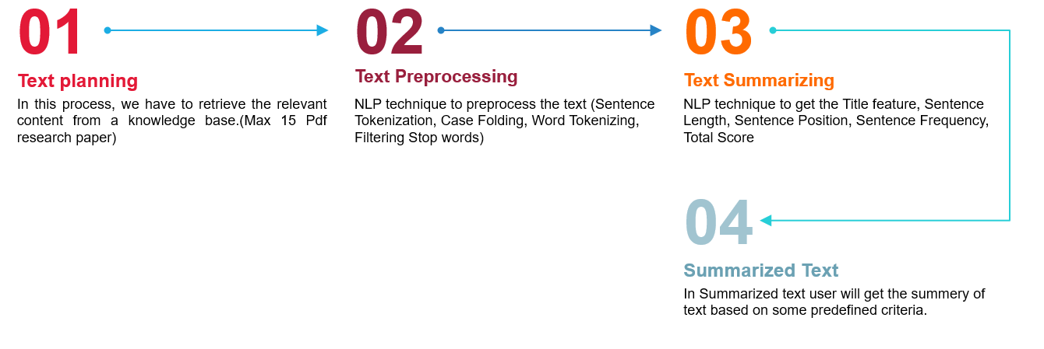

**Fig 1**: Text Pre-process Flow

**8.4 Text planning**

In this process, we have to retrieve the relevant content from a knowledge base. (Max 15 Pdf research paper)

**8.5 Text Processing**

NLP technique to preprocess the text (Sentence Tokenization, Case Folding, Word Tokenizing, Filtering Stop words)

8.6 **Text Summarizing**

NLP technique to get the Title feature, Sentence Length, Sentence Position, Sentence Frequency, Total Score.

**8.7 Summarized Text**

In Summarized text user will get the summary of text based on some predefined criteria.

# Chapter 9: Data Modelling

Data modelling is the manner in which data is evaluated. An effective evaluation requires preciseness. This is why seven means have been taken into account. These include the procedures of the (Text Rank, Lex Rank, LSA, Luhan, KL Sum, BERT, GPT-2) and three evaluation matrices (Rough-1, Blue score, Bert Score) which have been used.

The aim is to understand the underlying efficiency of all these and any problems which occur will result in the negation of the same. This would lead to a narrower process of analysis.

**TextRank:**

* TextRank is an extractive summarization technique.
* It is based on the concept that words which occur more frequently are significant.
* Hence, the sentences containing highly frequent words are important.
* Based on this, the algorithm assigns scores to each sentence in the text.
* The top-ranked sentences make it to the summary.

**Fig 2**: Text Rank Architecture

**Latent Semantic Analysis:**

* Latent Semantic Analysis is an unsupervised learning algorithm that can be used for extractive text summarization.
* It extracts semantically significant sentences by applying singular value decomposition(SVD) to the matrix of term-document frequency.

**LexRank:**

* A sentence that is similar to many other sentences of the text has a high probability of being important.
* The approach of LexRank is that a particular sentence is recommended by other similar sentences and hence is ranked higher.
* The higher the rank, the higher is the priority of being included in the summarized text.

**Luhan:**

* Luhn Summarization algorithm’s approach is based on TF-IDF (Term Frequency-Inverse Document Frequency). It is useful when very low frequent words, as well as highly frequent words(stopwords), are both not significant.
* Based on this, sentence scoring is carried out and the high ranking sentences make it to the summary.

**KL-Sum:**

* Another extractive method is the KL-Sum algorithm.
* It selects sentences based on similarity of word distribution as the original text.
* It aims to lower the KL-divergence criteria (learn more).
* It uses a greedy optimization approach and keeps adding sentences till the KL-divergence decreases.

**BERT:**

* BERT Bidirectional transformer) is a transformer used to overcome the limitations of RNN and other neural networks as Long term dependencies. It is a pre-trained model that is naturally bidirectional. This pre-trained model can be tuned to easily perform the NLP tasks as specified, Summarization in our case.

[. Image source](https://cdn.analyticsvidhya.com/wp-content/uploads/2021/02/DIAGRAM-EXPORT.png)

**Fig 3**: BERT Architecture

**GPT-2:**

* GPT-2 is a seq2seq model, it can also be fine-tuned for the task of text summarization. Here the format of data is very similar to the translation task- “text = summary”.

[Image source](http://jalammar.github.io/illustrated-gpt2/)

**Fig 4**: GPT-2 Architecture

**Chapter 10: Data Evaluation**

The evaluation of the same has been performed keeping in mind the pros and cons of every procedure. The proposed model has been run across the different models for evaluation purposes.

There are seven text analytics algorithms (Text Rank, Lex Rank, LSA, Luhan, KL Sum, BERT, GPT-2) and three evaluation matrices (Rough-1, Blue score, Bert Score) which have been used. Of these, the most suitable has resulted in optimal results.

Evaluation research proposals are used to negotiate a study commission, project contract, and/or to carry out the actual evaluation research study. Once a study is finished, a written assessment report must be submitted.

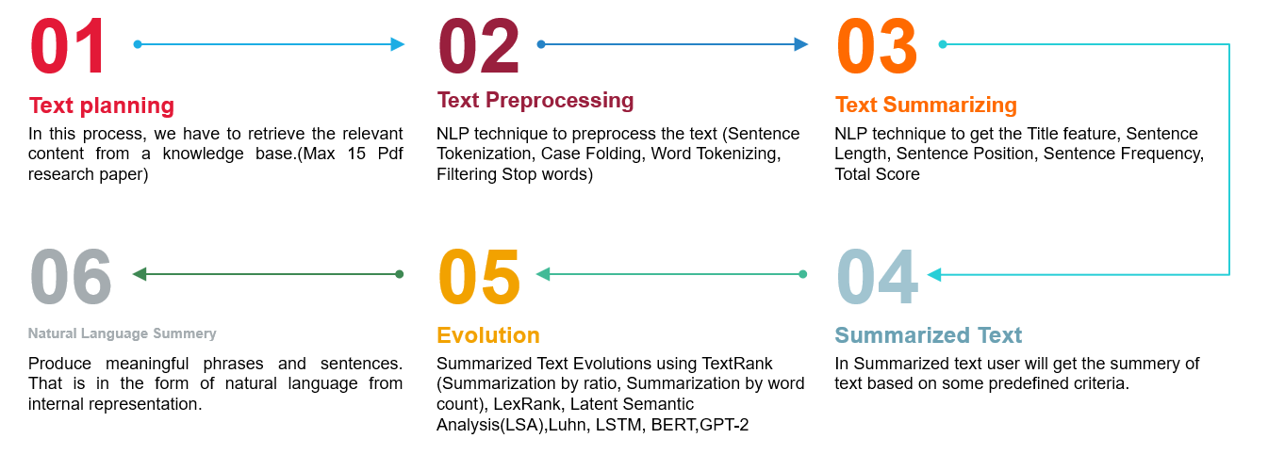

**Fig 5**: Text Evaluation Process

Literature reviews must be examined and evaluated in the same manner as empirical papers are, but is this always the case? According to Palmatier et al. (2018), a great literature review must have both depth and rigour, that is, it must exhibit an adequate approach for picking articles, collecting data and ideas, and offering something more than a recitation of prior research. Furthermore, they argue that a quality literature review must be reproducible, which means that the technique must be explained in such a way that an external reader might duplicate the study and obtain comparable conclusions. Finally, they say that a literature review must be beneficial to both researchers and practitioners. However, assessing various forms of literature reviews can be difficult. As a result, certain guidelines for writing literature review articles across methods are proposed as a starting point to assist editors, reviewers, writers, and readers in assessing literature reviews. These differ from the various stages of doing a literature review and should be wide enough to include the majority of types of literature reviews. However, when assessing an individual review, particular requirements for the kind of review must be evaluated to see whether the review fulfils the rigour and depth criteria. Different criteria may be valid depending on whether the review is systematic, semi-systematic, or integrative. But even so, regardless of the kind of review, pay particular attention to which studies were selected and for what reasons, since these decisions make all the difference in terms of the sort of conclusions reached by the authors. Ignoring a key topic of research, particular journals, or years might have serious repercussions for the study's results and conclusions. Furthermore, its contribution should always be weighed against the topic or sector to which it contributes. What is an auspicious contribution in one area, maybe inadequate in another?

# Chapter 11: Deployment

The model has not been deployed as of yet even though the eight models have been used for the summarizing review in Generating Literature Review for Research Paper in the field of Text Analytics.

# Chapter 12: Analysis and Result

After you have gathered the articles for your literature review, you are ready to evaluate each one (break it down and locate the key information in it) and then synthesise the collection of articles (integrate them and identify the conclusions that can be drawn from the articles as a group). To begin, it is best to go through the articles that have been compiled to get a feel of what they are about. Most published papers provide a summary or abstract at the beginning of the publication, which will aid in this process and allow you to decide whether it is worth further reading or inclusion. At this stage, it may also be beneficial to do an initial categorization and grouping of the articles based on the kind of source (Cronin, et al, 2008).

A variety of tools are available to assist us in analysing and synthesising our essential sources. Using a synthesis matrix to organise and integrate the sources in your literature review not only acts as the foundation of your study but also contributes to the discourse in your area and enhances your reputation as a scholar. A matrix can be structured in an infinite number of ways (Sally, 2013).

A synthesis matrix, for example, is structured by the major research on your specific issue. Choose six to twelve papers that are closely connected to the subject of your research that will serve as the foundation for your suggested research. List the author and date of publication for each research in the first column along the table's vertical axis (Sally, 2013). Next, create columns for the study's goal or research questions, the study's technique and sample, the study's primary findings, the study's core concepts or themes, how the findings corroborate those of other studies (similarities), and how the findings differ from others or provide information not found elsewhere (differences).

This part of the research enumerates the result and its analysis: of the repercussions of the achieved result. This is inclusive of the outcome of the proposed methodology and covers descriptive work.

The outcome was best when the GPT-2 was adopted as the procedure as it showed a better performance in the field of text generation in the field of **Generating Literature Review for Research Paper**

**Bert text generation report:**

BERT Bidirectional transformer) is a transformer used to overcome the limitations of RNN and other neural networks as Long term dependencies. It is a pre-trained model that is naturally bidirectional. This pre-trained model can be tuned to easily perform the NLP tasks as specified, Summarization in our case.

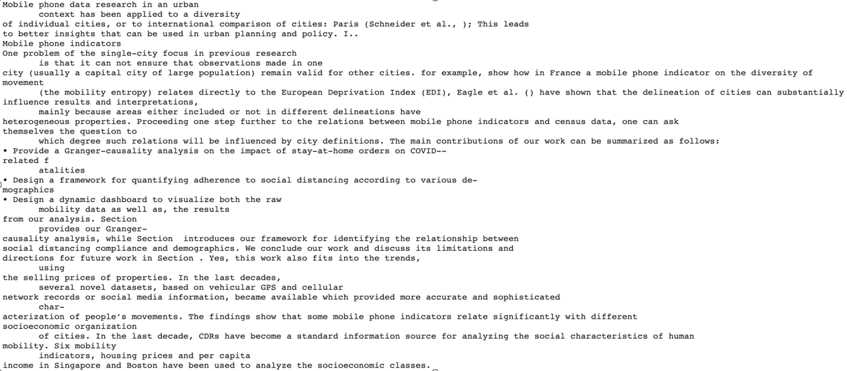

Fig 6 : Bert Text Summary

**GPT-2 text generation report:** GPT-2 is a seq2seq model, it can also be fine-tuned for the task of text summarization. Here the format of data is very similar to the translation task- “*text = summary”.*

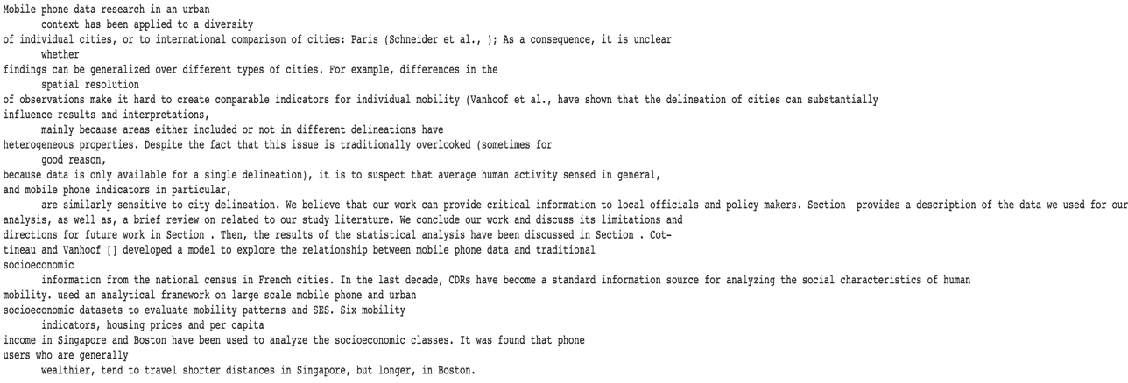

Fig 7: GPT-2 Text Summary

**Result Matrices Evolution :**

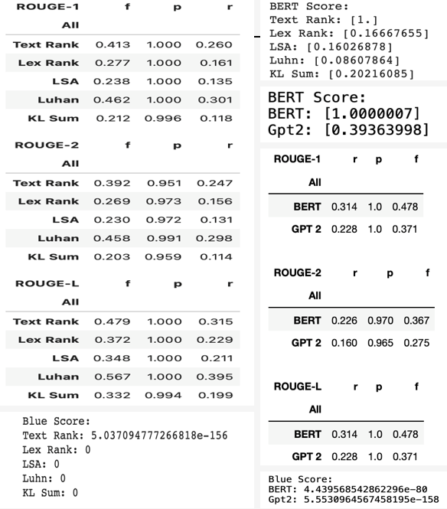

Fig 8: Result Matrices Evolution

# Chapter 13: Conclusions and Future Scope

Literature reviews serve as a vital basis for all sorts of research. They can serve as a foundation for knowledge growth, produce policy and practise recommendations, offer proof of an effect, and, if effectively performed, have the potential to generate new ideas and directions for a certain subject. As so, they provide the foundation for future study and theory. However, both performing and assessing a literature review may be difficult, which is why this paper provides some basic suggestions on how to conduct better, more thorough literature reviews and, in the long run, simply better research. It will be much easier to identify actual research gaps rather than simply repeating the same research, to develop better and more precise hypotheses and research questions, and, as a result, to improve the quality of research as a community, if there is a certainty that the research is built on great accuracy.

This article provided a thorough guide to creating a systematic literature review. This guide provides a step-by-step strategy to carrying out the rigorous, scientific process of a systematic literature review. While worded broadly enough to be applicable to a wide range of subjects, it is especially relevant to social sciences and management.

Whether the method is qualitative or quantitative will frequently determine when and how it is implemented. Depending on the reasons for doing the study and the general goals and objectives of the research, several forms of literature reviews may be employed.

A literature review might be thorough or selective, but it should look at seminal or major works as well as those that have had an impact on the area. The breadth of a literature review will differ depending on the task and field. The literature review might be part of a bigger work or a stand-alone piece, which means it is the whole study. In order to establish an author's unique study, it might be included as either a part of the introduction or as a distinct portion of a thesis, dissertation, or even as a research report. Writing a review of the literature is a talent that must be honed. Students and researchers may participate in improving knowledge via evidence-based practice by conducting them.

# Bibliography:

Prager, J. (2006). Open-domain question-answering. Foundations and Trends in Information Retrieval, 1(2), 91–233. <https://doi.org/10.1561/1500000001>

Srivastava, A., Singh, V., & Drall, G. S. (2019). Sentiment analysis of twitter data: A hybrid approach. International Journal of Healthcare Information Systems and Informatics, 14(2), 1–16. <https://doi.org/10.4018/IJHISI.2019040101>

Carnwell, R., & Daly, W. (2001) Strategies for the Construction of a Critical Review of the Literature. Nurse Educ Pract 1: 57-63

Colling, J (2003). Demystifying The Clinical Nursing Research Process: The Literature Review. Urol Nurs 23 (4): 297–9.

Cooper, H. M. (1988). The Structure of Knowledge Synthesis. Knowledge in Society, 1: 104-126.

Cronin, P., Ryan, F., & Coughlan, M. (2008). Undertaking a literature review: a step-by-step approach. British Journal of Nursing, 17(1): 38-43.

Emerald Group Publishing (n.d.) How to Write a Literature Review. Retrieved from <http://www.emeraldgrouppublishing.com/authors/guides/write/literature.htm>.

Galvan, J. L. (2006). Writing literature reviews. Glendale, CA: Pyrczak Publishing.

Hall, T., Beecham, S., Bowes, D., Gray, D., & Counsell, S. (n.d.). A Systematic Literature Review on Fault Prediction Performance in Software Engineering. Hart, C. (1998). Doing a Literature Review. London: Sage Publications.

Lawrence, C. N. (2011). Writing a Literature Review in the Social Sciences. Retrieved from [www.academic.edu](http://www.academic.edu).

Okoli, C., & Schabram, K. (2010). A Guide to Conducting a Systematic Literature Review of Information Systems Research. Sprouts: Working Papers on Information Systems, 10(26).

Sally. (2013). A Synthesis Matrix as a Tool for Analysing and Synthesizing Prior Research. Retrieved from

http://www.academiccoachingandwriting.org/dissertation-doctor/dissertation-doctor-blog iii-a-synthesis-matrix-as-a-tool-for-analyzing-and-synthesizing-prior-research

Carnwell, R., & Daly, W. (2001) Strategies for the Construction of a Critical Review of the Literature.

Nurse Educ Pract 1: 57-63

Colling, J (2003). Demystifying The Clinical Nursing Research Process: The Literature Review. Urol

Nurs 23 (4): 297–9.

Cooper, H. M. (1988). The Structure of Knowledge Synthesis. Knowledge in Society, 1: 104-126.

Cronin, P., Ryan, F., & Coughlan, M. (2008). Undertaking a literature review: a step-by-step

approach. British Journal of Nursing, 17(1): 38-43.

Emerald Group Publishing (n.d.) How to Write a Literature Review. Retrieved from

http://www.emeraldgrouppublishing.com/authors/guides/write/literature.htm.

Galvan, J. L. (2006). Writing literature reviews. Glendale, CA: Pyrczak Publishing.

Hall, T., Beecham, S., Bowes, D., Gray, D., & Counsell, S. (n.d.). A Systematic Literature Review on

Fault Prediction Performance in Software Engineering.

Hart, C. (1998). Doing a Literature Review. London: Sage Publications.

Lawrence, C. N. (2011). Writing a Literature Review in the Social Sciences. Retrieved from

www.academic.edu.

Okoli, C., & Schabram, K. (2010). A Guide to Conducting a Systematic Literature Review of

Information Systems Research. Sprouts: Working Papers on Information Systems, 10(26).

Sally. (2013). A Synthesis Matrix as a Tool for Analysing and Synthesizing Prior Research. Retrieved

from http://www.academiccoachingandwriting.org/dissertation-doctor/dissertation-doctor-blog

iii-a-synthesis-matrix-as-a-tool-for-analyzing-and-synthesizing-prior-research

San Jose State University (n.d.) Guidelines for Writing a Review of Literature Retrieved from

http://www.sjsu.edu/faculty/christen/review_guidelines.html\.

The University of North Carolina at Chapel Hill (n.d.) The Writing Centre, Literature Review.

Retrieved from https://writingcenter.unc.edu/files/2012/09/Literature-Reviews-The-Writing-

Center.pdf.

Timmins, F., & McCabe, C. (2005). How to conduct an effective literature review. Nurs Stand, 20

(11): 41–7.

USC Libraries. (n.d.) Organizing Your Social Sciences Research Paper. Retrieved from

http://libguides.usc.edu/writringguide/literaturereview.

Younger, P. (2004). Using the internet to conduct a literature search. Nurs Stand 19 (6): 45-51

San Jose State University (n.d.) Guidelines for Writing a Review of Literature Retrieved from [http://www.sjsu.edu/faculty/christen/review_guidelines.html\](http://www.sjsu.edu/faculty/christen/review_guidelines.html%5C).

The University of North Carolina at Chapel Hill (n.d.) The Writing Centre, Literature Review. Retrieved from <https://writingcenter.unc.edu/files/2012/09/Literature-Reviews-The-Writing-Center.pdf>.

Timmins, F., & McCabe, C. (2005). How to conduct an effective literature review. Nurs Stand, 20 (11): 41–7.

USC Libraries. (n.d.) Organizing Your Social Sciences Research Paper. Retrieved from <http://libguides.usc.edu/writringguide/literaturereview>.

Younger, P. (2004). Using the internet to conduct a literature search. Nurs Stand 19 (6): 45-51

Baumeister, R. F., & Leary, M. R. (1997). Writing narrative literature reviews. Review of General Psychology, 1, 311–320. <https://doi.org/10.1037/1089-2680.1.3.311>.

Borman, G. D., & Dowling, N. M. (2008). Teacher attrition and retention: A meta-analytic and narrative review of the research. Review of Educational Research, 78, 367–409. <https://doi.org/10.3102/0034654308321455>.

Boyd, B. K., & Solarino, A. M. (2016). Ownership of corporations: A review, synthesis, and research agenda. Journal of Management, 42, 1282–1314. <https://doi.org/10.1177/0149206316633746>.

Braun, V., & Clarke, V. (2006). Using thematic analysis in psychology. Qualitative Research in Psychology, 3,77–101. <https://doi.org/10.1191/1478088706qp063oa>.

Carlborg, P., Kindström, D., & Kowalkowski, C. (2014). The evolution of service in-novation research: A critical review and synthesis. The Service Industries Journal,34(5), 373–398. <https://doi.org/10.1080/02642069.2013.780044>.

Carrillat, F. A., Legoux, R., & Hadida, A. L. (2018). Debates and assumptions about motion picture performance: A meta-analysis. Journal of the Academy of Marketing Science, 46,273–299. <https://doi.org/10.1007/s11747-017-0561-6>.

Chang, W., & Taylor, S. A. (2016). The effectiveness of customer participation in new product development: A meta-analysis. Journal of Marketing, 80,47–64. <https://doi.org/10.1509/jm.14.0057>.